EUCALL task 4.2.2.10 – EXAFS modelling

In this example, we run through the requirements that are necessary for simulation (fitting) of EXAFS data relevant to a sample experiment obtain signal from a 5 µm thick Fe foil. The simulation will be carried out for ambient conditions Fe foil; *a future enhancement of SIMEX will take P-T conditions from hydrocode simulations before performing high-pressure XANES/EXAFS calculations.*

To validate the EXAFS simulations, we compare the simulated spectrum with raw data obtained from an X-ray absorption beamline at the ESRF synchrotron. The normalized XAS spectrum for a 5 µm thick Fe foil is shown in figure 1.

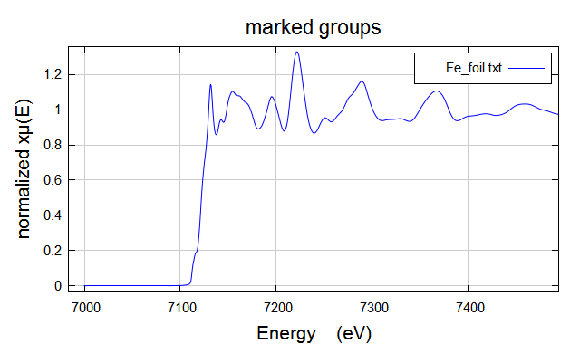

**Figure 1 :** X-ray absorption spectra collected at BM23 (EXAFS beamline, ESRF) of a 5 µm thick iron foil.

Calculations of XAFS spectra are performed using the FEFF package. FEFF uses a single input file to select which modules should be run inside the program and what parameters should be used. The material of interest is contained within this input file based on its crystallographic parameters and atomic positions. The ATHENA program is able to combine crystallographic input files (.cif format) for a chosen material into the FEFF .inp format. The .cif files can typically be found from most crystallographic database websites or can be manually created using gui programs such as VESTA. FEFF is then run to calculate the paths between atoms and is then saved / exported for use by other third party programs (such as ARTEMIS) to compare with actual data.

# Artemis User Guide

A more comprehensive user guide for running ARTEMIS / FEFF can be found here:

<http://bruceravel.github.io/demeter/artug/index.html>

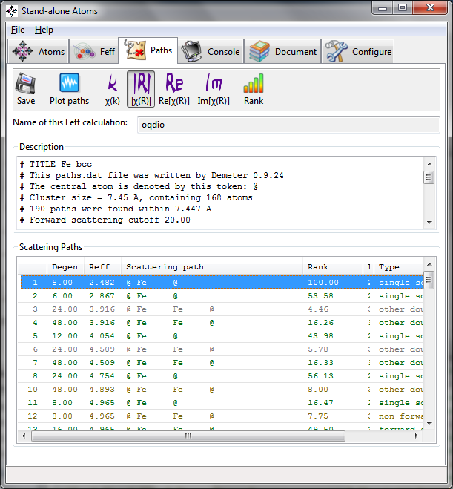

**Figure 2:** Screenshot of the output data collected in the ATOMS software after running Feff simulation of Fe at ambient conditions.

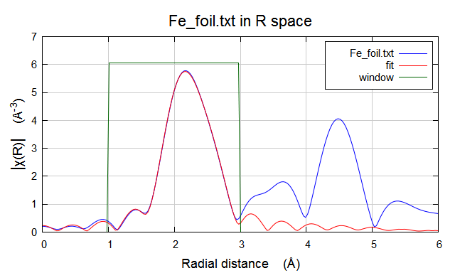

**Figure 3:** Fitting of the first Fe shell from FEFF calculations (red) to Fe EXAFS data collected on BM23 beamline, ESRF (blue)

# Simulating XANES at shock conditions

Shock compression experiments on Fe have previously been carried out at the ESRF (R. Torchio *et al.* Scientific Reports **7**(1) 26402 (2016)). In that study, simulations of the XANES at shock conditions were carried out using the ABINIT code and are shown below in figure 4.

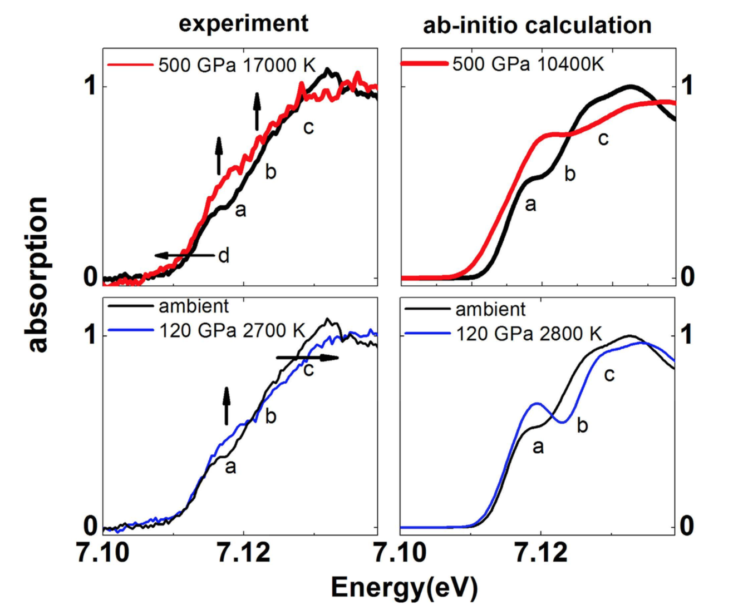

**Figure 4:** Comparisons of the absorption edge of Fe between experiments (left panels) and ab-initio calculations (right panels) at 120 and 500 GPa. [Figure taken from Scientific Reports **7**(1) 26402 (2016)]

# Further reading

Torchio, R. *et al.*

Probing local and electronic structure in Warm Dense Matter: single pulse synchrotron x-ray absorption spectroscopy on shocked Fe.

*Scientific Reports 2017 7:1* **6,** srep26402 (2016).

Harmand, M. *et al.*

X-ray absorption spectroscopy of iron at multi megabar pressures in laser shock experiments.

*Phys. Rev. B* **92,** 024108–7 (2015).

Mazevet, S. *et al.*

Ab initio calculation of x-ray absorption of iron up to 3 Mbar and 8000 K.

*Phys. Rev. B* **89,** 111–5 (2014).